**Jenkins Configure in to EC2**

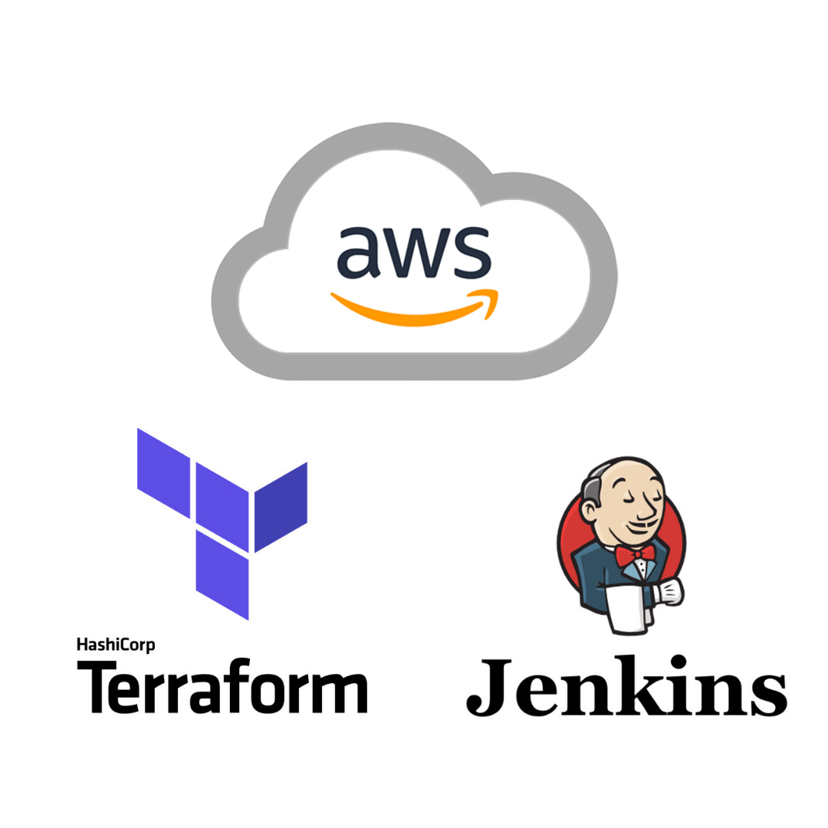

**Create Ec2 instance with 2 CPU’s 2gb ram t2.medium**

**Create Iam role and give required permissions (if you are creating s3 bucket give s3 permission to ec2 role) and attach to Ec2**

**Install below commands into Ec2 instance**

**#!/bin/bash (if user want to run through shell script all commands you can create file and copy th commands and run it**

**Vi file.sh**

**Sh test.sh #to run**

**Or you can run manually one by one commands**

**Ex:** 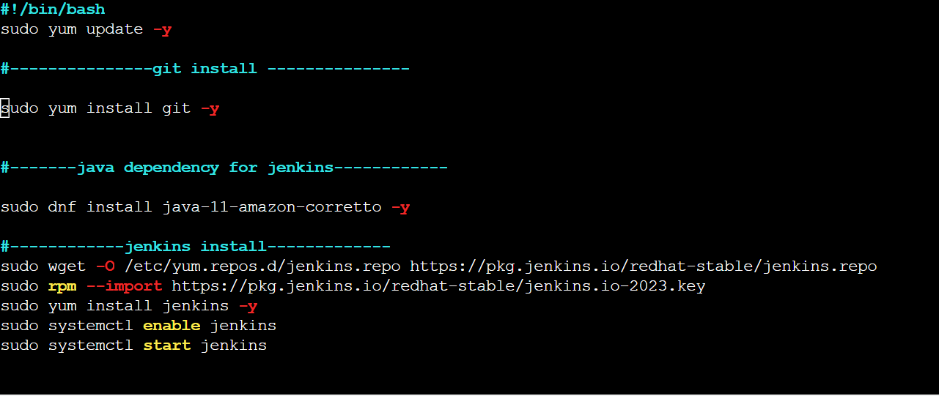

**sudo yum update -y**

**#---------------git install ---------------**

**sudo yum install git -y**

**#-------java dependency for jenkins------------**

**sudo dnf install java-11-amazon-corretto -y**

**#------------jenkins install-------------**

**sudo wget -O /etc/yum.repos.d/jenkins.repo https://pkg.jenkins.io/redhat-stable/jenkins.repo**

**sudo rpm --import https://pkg.jenkins.io/redhat-stable/jenkins.io-2023.key**

**sudo yum install jenkins -y**

**sudo systemctl enable jenkins**

**sudo systemctl start jenkins**

**# ------------------install terraform ------------------**

**sudo yum install -y yum-utils**

**sudo yum-config-manager --add-repo https://rpm.releases.hashicorp.com/AmazonLinux/hashicorp.repo**

**sudo yum -y install terraform**

**after install all dependencies (git, Jenkins and terraform)**

**Jenkins port number is 8080 so user has to open 8080 port I ec2 sg groups**

**Open your local browser and enter the PUBLIC IP of your EC2 Instanc**

[**http://[YOUR-EC2-LINUX2-INSTANCE-IP]:8080/**](http://[your-ec2-linux2-instance-ip]:8080/)

**e.g:**[**http://3.101.155.183:8080/**](http://3.101.155.183:8080/)

**Step 9: To get the initial password, open or cat your initial admin password file:**

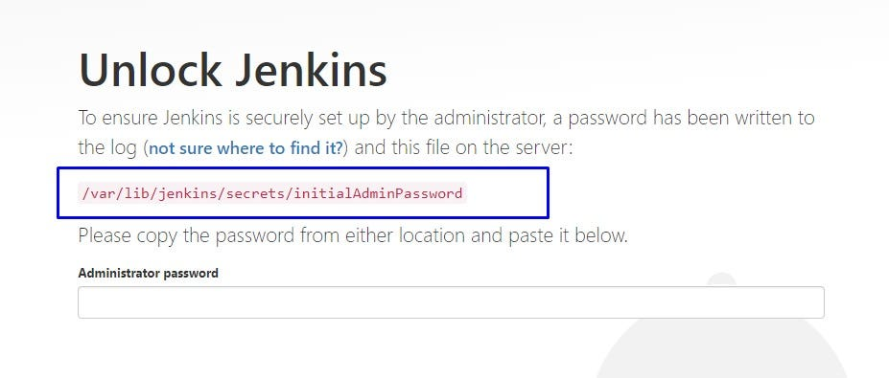

**SSH into your Jenkins server and get the Admin password:**

**sudo cat /var/lib/jenkins/secrets/initialAdminPassword**

**Copy the password to the password field.**

**Step 10: Select “Install suggested plugins”**

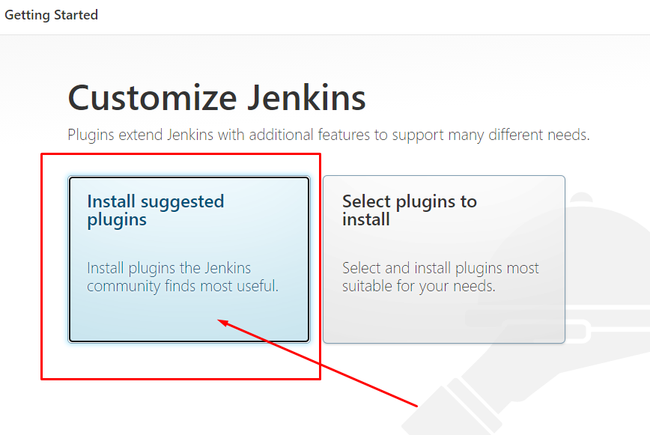

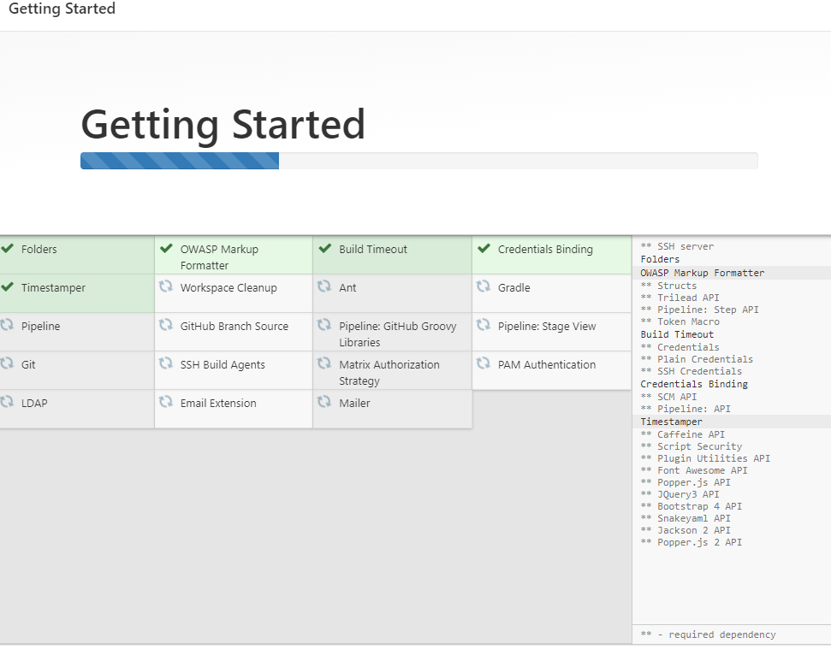

**Step 11: Create A New Admin Password**

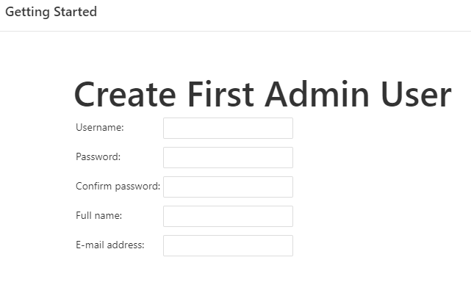

**Step 12: Click “Save and Finish”**

(Do not change to localhost)

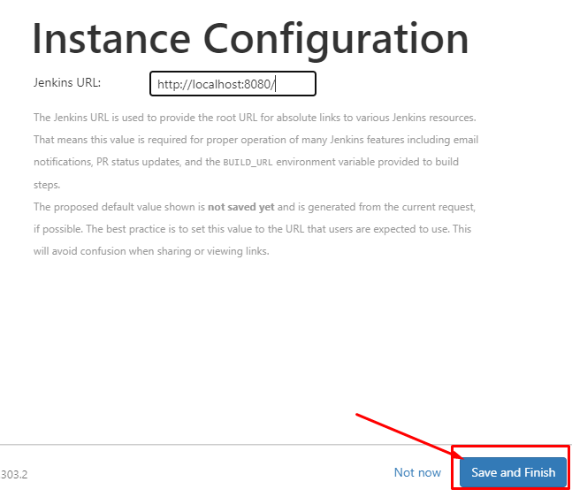

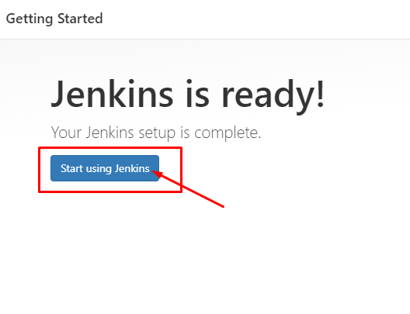

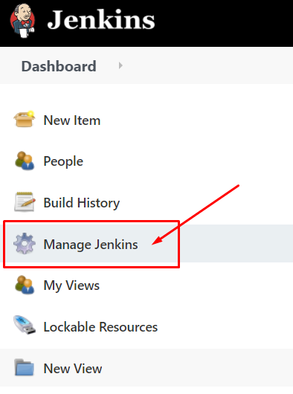

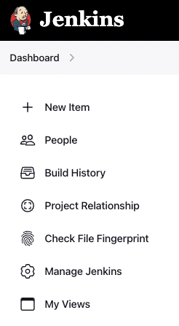

Next, click on the “Manage Plugins” icon to install the Terraform plugin.

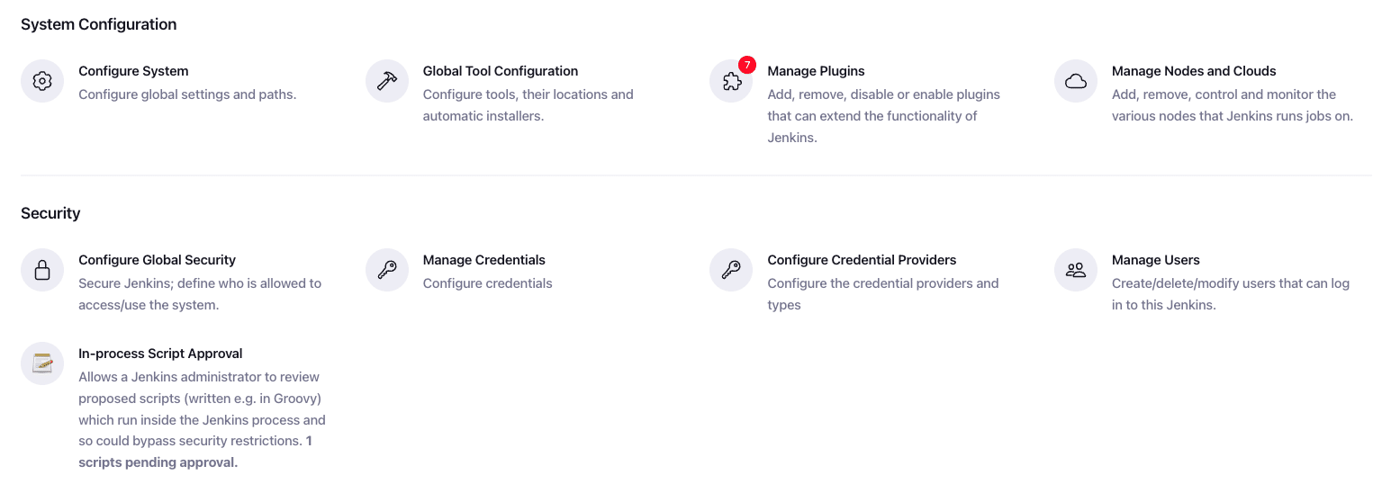

Click on the “Available plugins” tab in the left navigation menu, and enter “Terraform” in the search bar.

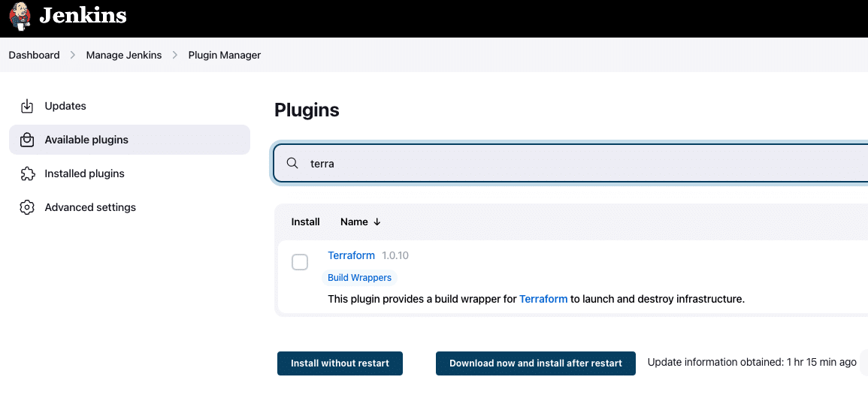

Mark the checkbox next to Terraform, and click on “Install without restart.”

Once the installation is successful, it is displayed on the progress screen, as shown below. We have the option to restart Jenkins after this step.

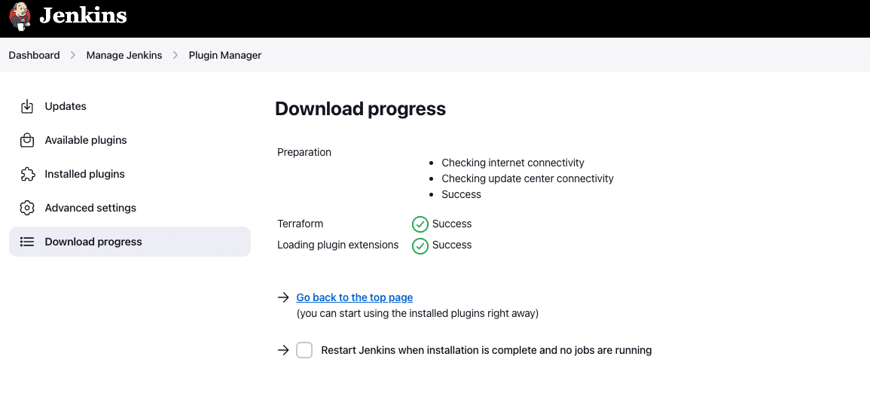

We have successfully installed the Terraform plugin in Jenkins.

To confirm the changes we made, navigate to the same path, and see if it is available and enabled in the “Installed plugin” section.

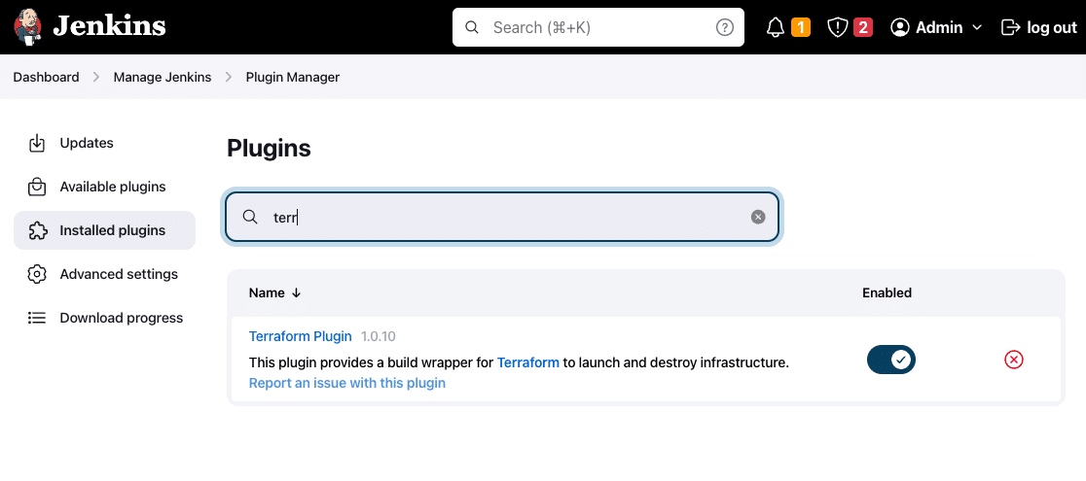

**Create Your First Job**

**Step 1)**Goto Jenkins Home > New Item > Create Project with Pipeline.

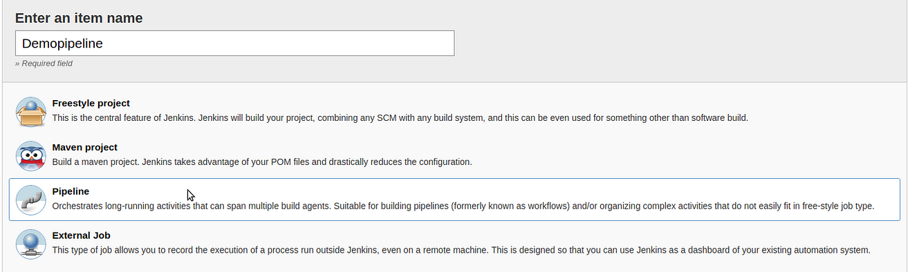

After creating Pipeline Project it will display this view

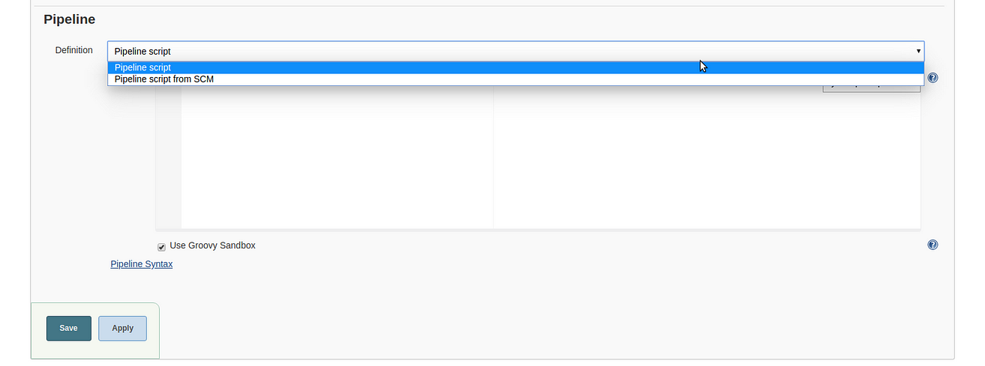

Here we go, Now we create our first Jenkins Pipeline.

pipeline {

agent any

stages {

stage('checkout') {

steps {

git branch: 'main', url: 'https://github.com/CloudTechDevOps/Terraform.git'

}

}

stage('init') {

steps {

sh "terraform init -reconfigure"

}

}

stage('plan') {

steps {

sh "terraform plan"

}

}

stage('action') {

steps {

sh "terraform ${action} --auto-approve"

}

}

}

}

When we run our Jenkins Pipeline job we can see this type of layout

